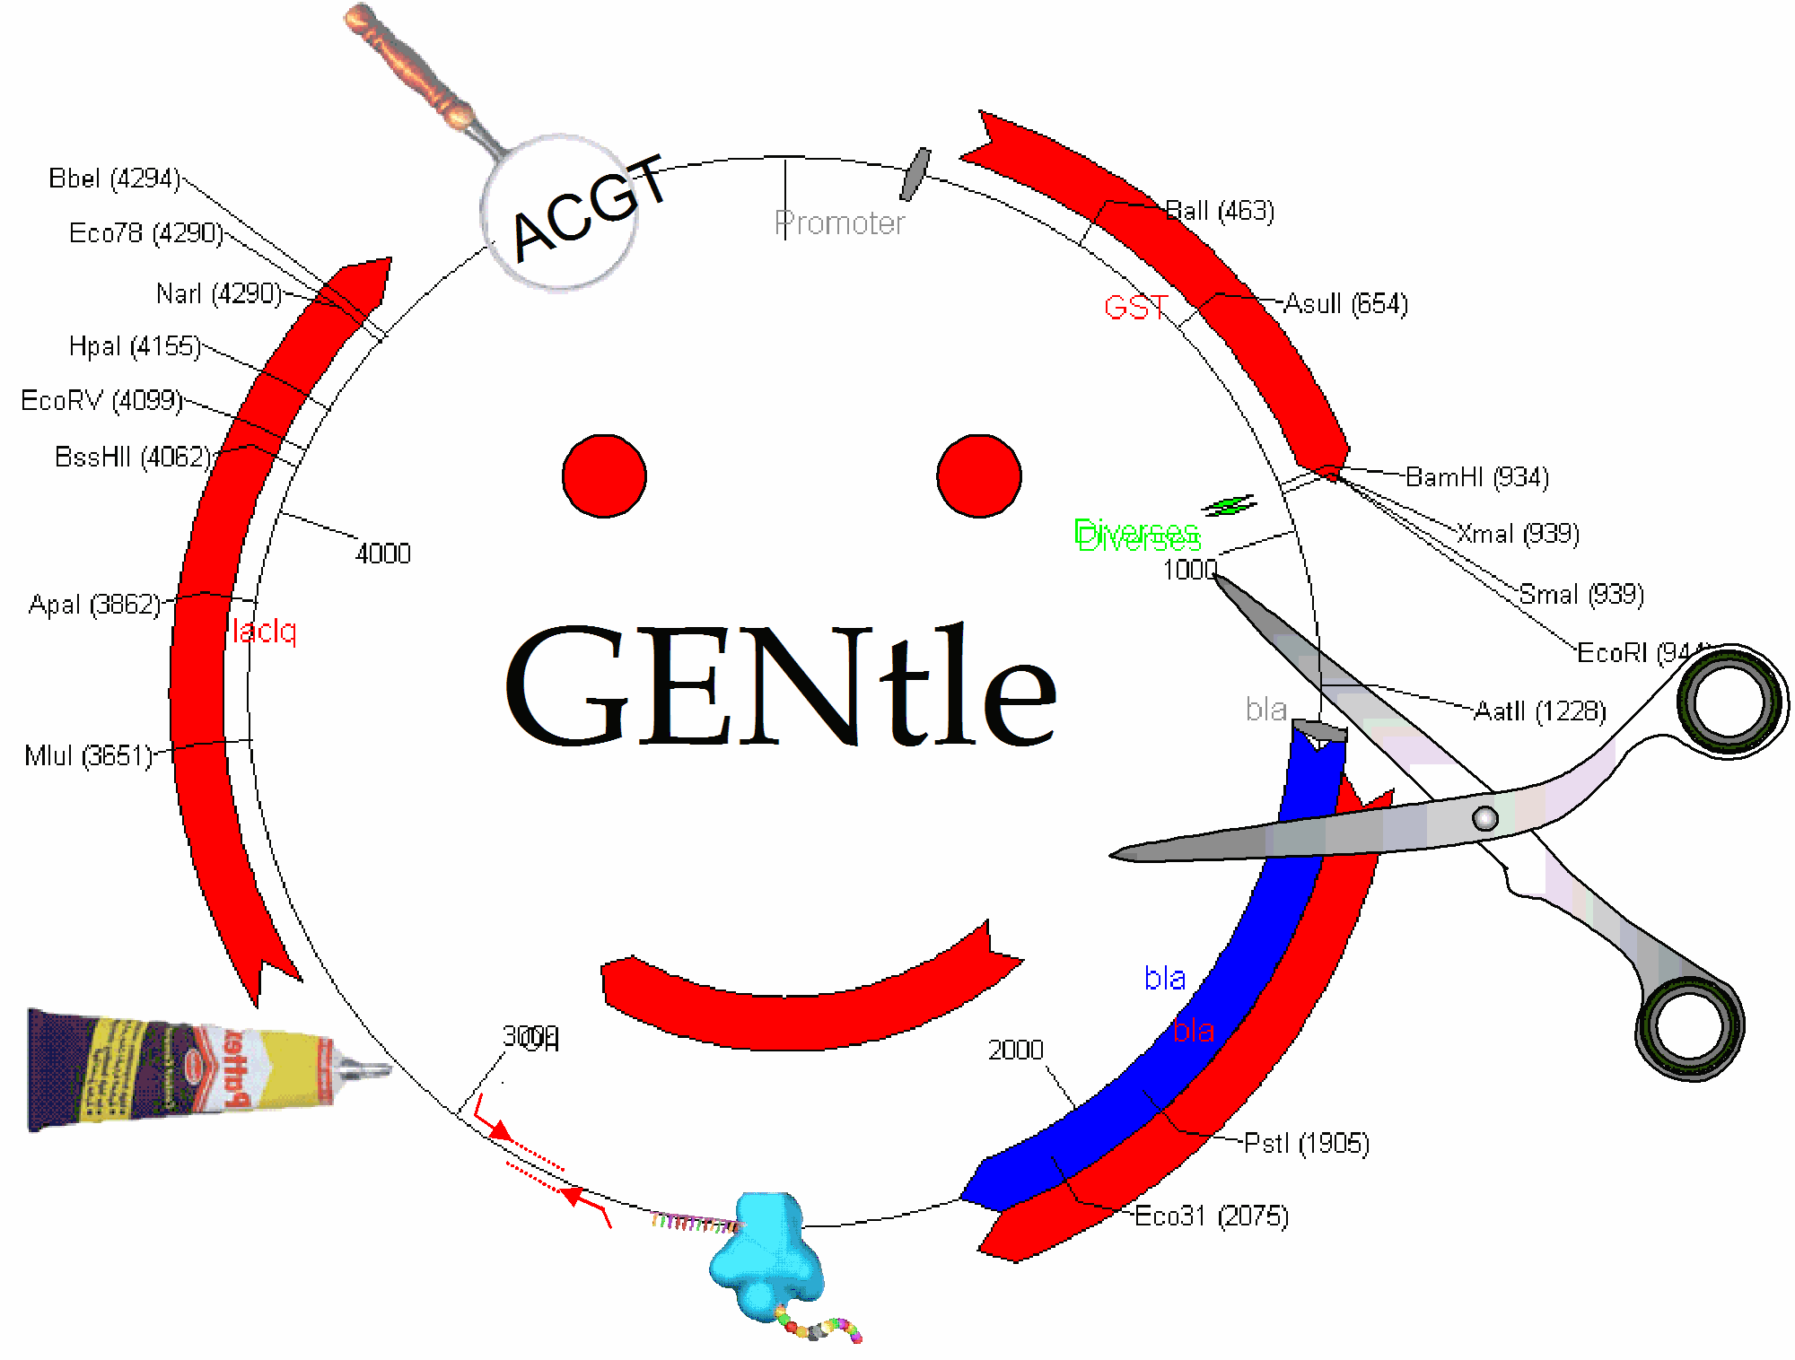

The Manual
Version of March 2005

Table of Contents
I. About 4
1. Conventions 4
2. Copyright 4
II. DNA 4
1. Open and display DNA 4
2. Toolbar 4
3. Detail tree 5
4. Special menus 5
5. DNA map 5
6. Display 5
7. Mouse actions 5
8. Context menu 6
9. Sequence map 8
10. Clicks 8
11. Context menu 8
12. Keys 9
13. Edit mode 9
14. Horizontal mode 9
III. Protein 10
1. Toolbar 10
2. Function display 10
3. Special menus 10
IV. PCR and Primer Design 11
1. Toolbar 11
2. Primer list 11
3. Sequence 11
V. Sequencing 12
1. Display 12
2. Toolbar 13
3. Caveats 13
VI. Alignments 13
1. Settings dialog 13
2. Toolbar 13
3. View menu 14
4. Sequence display 14
VII. Calculators 14
1. Ligation calculator 14
2. DNA concentration calculator 14
3. Protein calculator 15
4. Data 15
VIII. Virtual Gel 15
IX. Image Viewer 15
X. Web interface 16
1. NCBI 16
2. PubMed 16
3. BLAST 16
XI. Tools 16
1. Ligation 16
2. Options 17
3. Databases (Open/save/manage) 18
4. Import 20
5. Enter sequence 20
6. Find dialog 21
7. Sequence editor 21
8. Restriction Assistant 23
9. Projects 24
10. Edit primer dialog 24
11. Printing 25
12. Enzyme management 25
13. Sequencing Primers 25
14. Silent Mutation 26
15. Automatic annotation 26
XII. FAQ 26

About
GENtle is an open source software for molecular biology. It is available at http://gentle.magnusmanske.de.

Conventions
- Keys are marked like this
- Menus, Buttons etc. are marked like this
- "Double click" always refers to the left mouse button
- "Context menu" always refers to the popup menu that appears on clicking with the right mouse button

Copyright
- GENtle is ©2004 by Magnus Manske, licensed under GPL
- This manual is ©2004 by its authors, licensed under GFDL

DNA
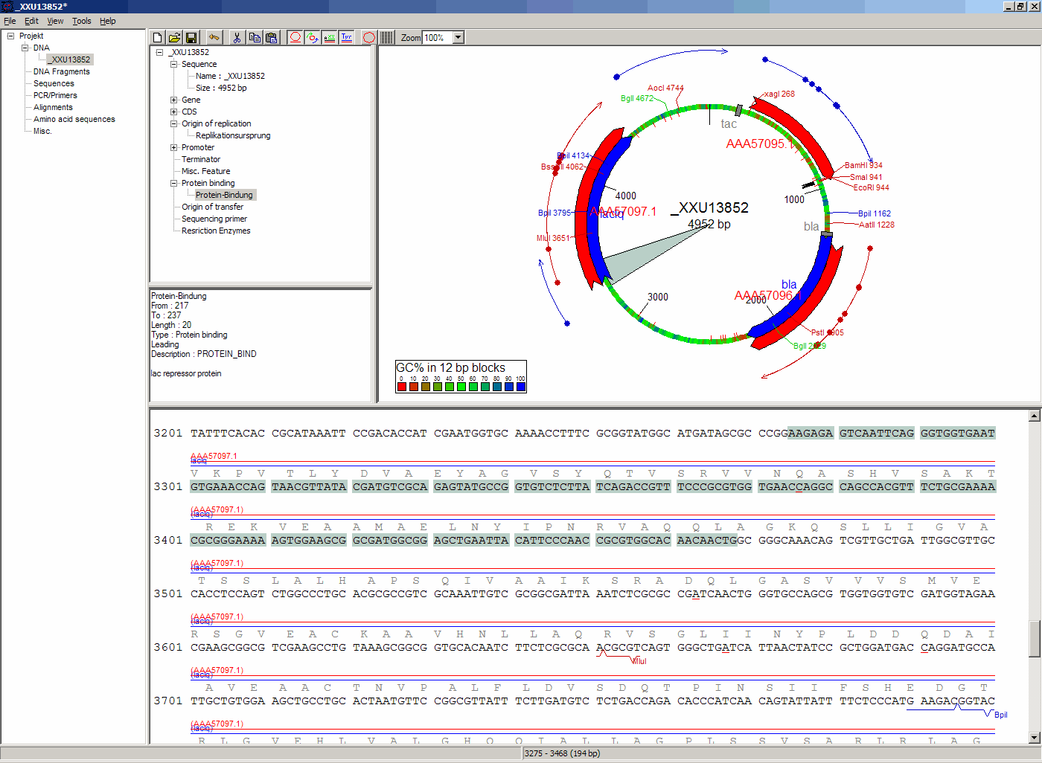
Within the DNA module, DNA sequences can be viewed, edited and annotated. It is the central module of GENtle. Two major components of the DNA module are the DNA map and the Sequence map; see there for details.

Open and display DNA
A DNA sequence can be opened in one of the following ways:
- Open from a database (see Databases)
- Import from file (see Import)
- Manual input (see Enter sequence)
- Create from another DNA module

Toolbar
Several functions and display options can be invoked in the tool bar:
- Enter sequence
- Open sequence
- Save sequence
- Undo
- Cut
- Copy
- Paste
- Toggle linear/circular
- Show/hide open reading frames
- Show/hide features
- Show/hide restriction sites
- Expand (=show only) map
- Toggle edit mode
- Zoom

Detail tree
The detail tree, left of the DNA map, shows all parts of the current sequence, including features and restriction enzymes, in a structured fashion. Features and restriction enzymes can be toggled in visibility by a double click, or further manipulated through the context menu.

Special menus
View/Show 3'->5' | Show the complementary DNA strand in the sequence map
Edit/Edit ORFs | Change the settings for open reading frame display
Edit/Show possible sequencing primers | Opens the Sequencing Primers dialog, which can add possible sequencing primers as features
Edit/Remove sequencing primers | Removes all sequencing primers generated by the above function from the sequence
Edit/Auto-annotate sequence | Finds features from common vectors and other databases in the current sequence
File/Print map | Prints the DNA map
File/Print sequence | Prints the Sequence map
File/Print report | Prints a brief overview. See Printing

DNA map
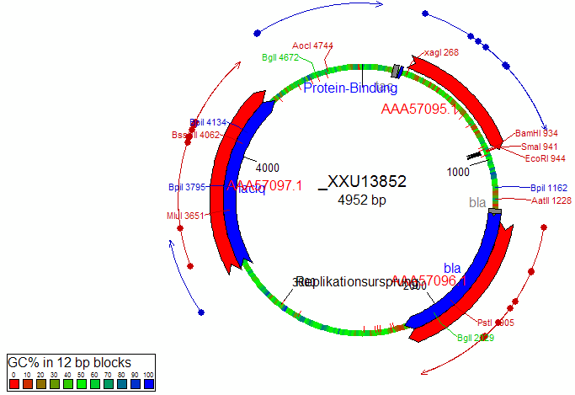
The DNA map is shown for DNA sequences (though a variant is also used in protein module for the schematics display). It shows the linear or circular (e.g., plasmid) DNA sequence as a map.

Display
Displayed are
- features (including optional sequencing primers)
- restriction sites
- sticky ends (if any)
- open reading frames (optional)
- sequence name and length (optional, see Options)
- methylation (optional, see Options)
- GC contents (optional, see Options)

Mouse actions
Action on | Mouse button | Function
Background | left | Mark sequence
Background | left (double click) | Open Sequence editor
Background | middle | Show marked DNA in sequence; show current position in sequence if nothing is marked
Feature | left | Move feature display
Feature | left (double click) | Edit feature (see Sequence editor)
Feature | middle | Mark DNA that matches feature
Feature | middle (shift pressed) | Extend currently marked area to include the DNA of the feature
Restriction site | left | Move site display
Restriction site | left (double click) | Edit enzyme list (see Sequence editor)
Restriction site | middle | Open Restriction Assistant
Open reading frame | left | Mark ORF sequence
Open reading frame | left (double click) | Mark and show ORF sequence
All | right | Context menu

Context menu
The context menu opens on a click with the right mouse button when somewhere inside the DNA map. The contents of the menu depends on what object in the map you clicked on. Also, depending on the properties of the object, some functions might not be available, for example, amino acids of a feature with no reading frame.

Background
Edit sequence | Opens the Sequence editor
Transform sequence | Make sequence inverted and/or complementary
Limit enzymes | Limits enzymes to thos that cut no more than n times
PCR/PCR | Starts the PCR modul
PCR/Forward | Starts the PCR modul and generates a 5'->3'-primer
PCR/Backward | Starts the PCR modul and generates a 5'->3'-primer
PCR/Both | Starts the PCR modul and generates both primers
PCR/Mutation | Starts the PCR modul and generates overlapping mutagenesis primers
Selection/Cut | Removes the selected part of the sequence and puts it into the clipboard
Selection/Copy | Copys the selected part of the sequence into the clipboard
Selection/Copy to new sequence | Genetate a new DNA sequence entry based on the selection
Selection/Show enzymes that cut here | Opens a variant of the Silent Mutagenesis dialog for the selected part of the sequence
Selection/Selection as new feature | Generates a new feature for the selected part of the sequence
Selection/Extract amino acids | Extracts the amino acid sequence of the selected part of the DNA sequence
Selection/BLAST amino acids | Runs a BLAST search for the amino acid sequence of the selected part of the DNA sequence
Selection/BLAST DNA | Runs a BLAST search for the selected part of the DNA sequence
Sequence map/Save as image | Saves the DNA map as an image file
Sequence map/Copy image to clipboard | Copies the DNA map as a bitmap or WMF (see Options) to the clipboard
Sequence map/Print map | Prints the DNA map
Show/hide ORFs | Toggles the open reading frame display
Edit ORFs | Adjusts the open reading frame display

Restriction sites
Edit restriction enzyme | Add/remove/manage restriction enzyme via the Sequence editor
Show/hide enzyme | Toggle visibility for the enzyme (this will affect all restriction sites for that enzyme in this sequence)
Remove enzyme | Remove the enzyme from the current selection (this will affect all restriction sites for that enzyme in this sequence).  This will not work for automatically added enzymes (see Options)
Mark restriction site | Marks the recognition sequence of that enzyme at that restriction site
Mark and show restriction site | Marks the recognition sequence of that enzyme at that restriction site and shows it in the sequence
Online enzyme information | Opens the ReBase (http://rebase.neb.com/rebase/rebase.html) page for that enzyme
Add to cocktail | This adds the enzyme to the restriction cocktail (see Restriction Assistant)
Add to cocktail | This adds the enzyme to the restriction cocktail (see Restriction Assistant) and starts the restiction

Features
Edit feature | Edit the feature properties (see Sequence editor)
Hide feature | Hide the feature from display
Delete feature | Delete the feature
DNA Sequence/Mark feature sequence | Mark the DNA sequence that matches the feature
DNA Sequence/Mark and show feature sequence | Mark the DNA sequence that matches the feature and shows it in the sequence
DNA Sequence/Copy (coding) DNA sequence | Copies the DNA sequence that matches the feature to the clipboard
DNA Sequence/This feature as new sequence | Generates a new DNA sequence based on the feature
DNA Sequence/BLAST DNA | Runs a BLAST search for the DNA of the feature
Amino acid sequence/Copy amino acid sequence | Copies the amino acid sequence of the feature to the clipboard
Amino acid sequence/As new entry | Generates a new protein entry based on the amino acid sequence of the feature
Amino acid sequence/Blast amino acids | Runs a BLAST search for the amino acid sequence of the feature

Open reading frames
As new feature | Generate a new feature from the ORF, with the appropriate reading frame and direction
DNA sequence/Copy DNA sequence | Copies the DNA sequence of the ORF to the clipboard
DNA sequence/As new DNA | Generates a new DNA sequence entry based on the DNA sequence of the ORF
DNA sequence/BLAST DNA | Runs a BLAST search for the DNA sequence of the ORF
Amino acid sequence/Copy amino acid sequence | Copies the amino acid sequence of the ORF to the clipboard
Amino acid sequence/As new AA | Generates a new protein entry based on the amino acid sequence of the ORF
Amino acid sequence/BLAST amino acids | Runs a BLAST search for the amino acid sequence of the ORF

Sequence map
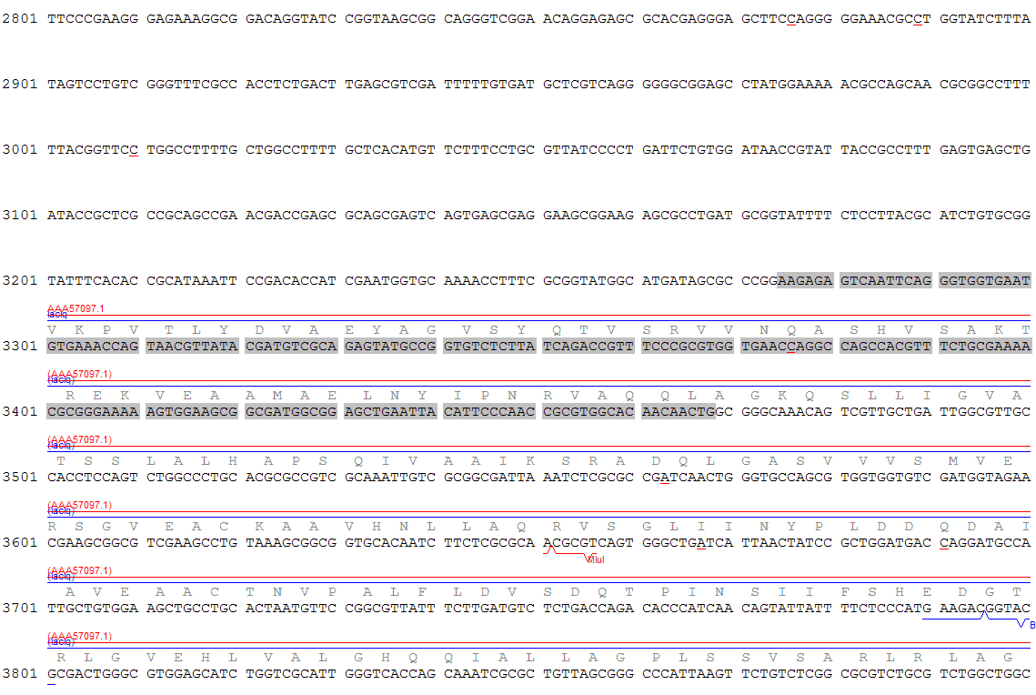
The sequence map is used by most GENtle modules. It shows sequences of DNA or amino acids, as well as primers, features, restriction sites and more. The basic behaviour, however, is always similar.

Clicks
A double click usuaqlly opens the editor for the sequence.

Context menu
The available functions in the context menu vary with the module the sequence map is used in, its state, and selection.
Edit sequence | Turn on edit mode
Transform sequence | Invert and/or complement the sequence (DNA module only)
Limit enzymes | Limit enzymes so that only enzymes below a certain number of cuts in the sequence is shown (DNA module only)
PCR | Compare DNA map
Selection | Compare DNA map
Copy as image | Copys the sequence map as a bitmap to the clipborad (Caveat : Such a bitmap can take up a huge amount of memory, depending on the length of the sequence)
Save as image | Saves the sequence map in one of several image formats
Print sequence | Prints the sequence

Keys
The whole sequence can be marked by Ctrl-A. The Find dialog can be invoked by Ctrl-F. Both functions can also be called upon through a menu.
In the DNA and PCR modules, the amino acid reading frame can be toggled by keys like this:
- Ctrl-1 = reading frame 1
- Ctrl-2 = reading frame 2
- Ctrl-3 = reading frame 3
- Ctrl-4 = reading frame 1, complementary strand
- Ctrl-5 = reading frame 2, complementary strand
- Ctrl-6 = reading frame 3, complementary strand
- Ctrl-7 = all reading frames, one-letter code
- Ctrl-8 = known reading frames only (from the features)
- Ctrl-0 = hide amino acids
- Ctrl-W = three-letter code (not when displaying all reading frames)
- Ctrl-Q = one-letter code

Edit mode
Display and edit mode can be toggled by F2 or the toolbar. During editing, the sequence display is maximized, and the DNA map is hidden, improving ease of edit. Depending on the current module, only some keys are allowed (in the DNA module, "A", "C", "G", and "T") by default; any other key will trigger a request to allow all keys for that sequence, for that session. The cursor can be moved similar to that in a text editor. Insert and overwrite mode can be toggled, except for some modules like PCR or Sequencing, where overwrite mode is mandatory. In these modules, backspace and delete are diasbeled as well.
When editing a primer in PCR mode, the "." key copies the base at the current position from the 3'→5' or 5'→3' sequence, respectively.

Horizontal mode
In some modules, the sequence display can be toggled to horizontal. This can enhance visibility. Printing, however, is always done in standard ("vertical") mode.

Protein
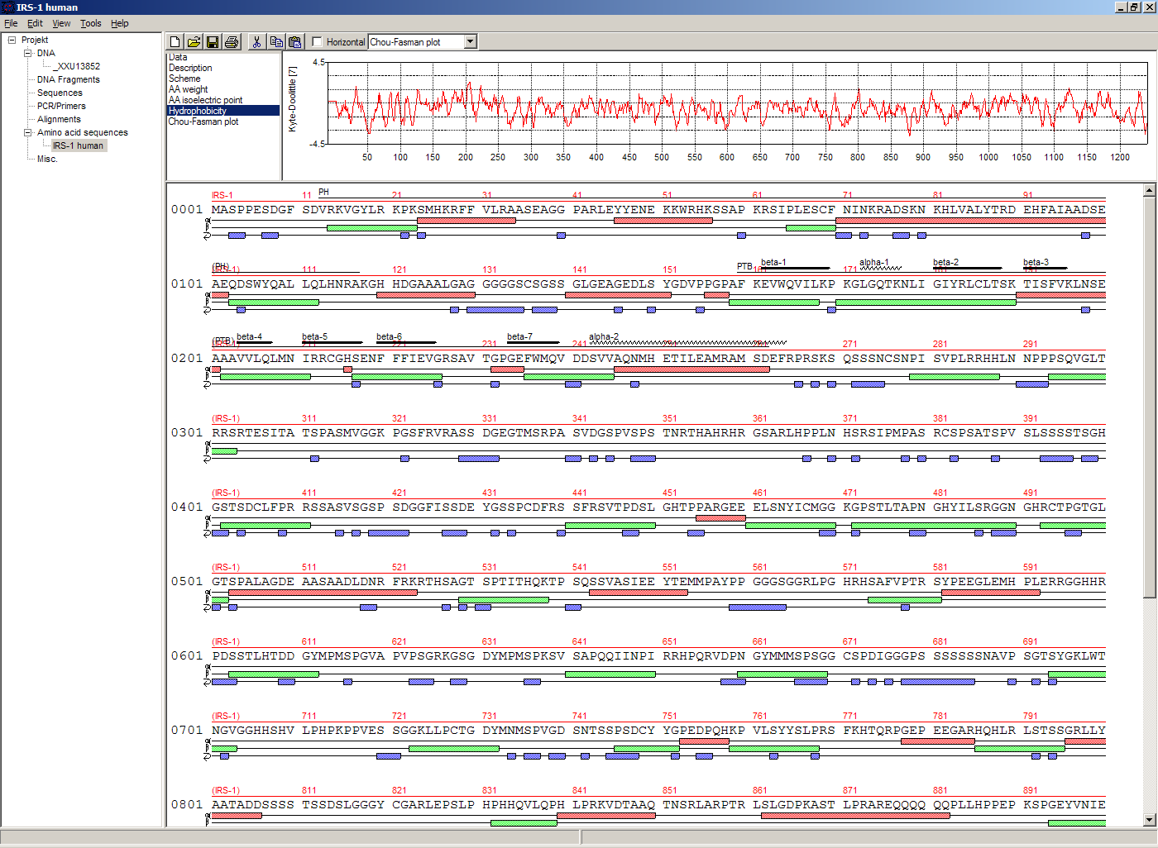
In this module, amino acid sequences (peptides/proteins) can be viewed, edited and annotated. It uses a sequence map as main display, and a multi-purpose overview display at the top.

Toolbar
Several functions and display options can be invoked in the tool bar:
- Enter sequence
- Open sequence
- Save sequence
- Print sequence
- Undo
- Cut
- Copy
- Paste
- Plot (shows a plot within the sequence map)
- Horizontal mode

Function display
The smaller display on the top can show several types of information:
Data | Shows some basic data that has been calculated from the sequence
Description | Shows the sequence description
Scheme | Shows a DNA map-like layout of the whole protein
AA weight | Shows a plot of the molecular weight of the individual amino acids
AA isoelectric point | Shows a plot of the isoelectric point of the individual amino acids
Hydrophobicity | Shows a plot of the local hydrophobicity of the amino acids nearby
Chou-Fasman plot | Shows a detailed Chou-Fasman-plot

Special menus
Edit/Photometer analysis | Invokes the respective calculator
Edit/'Backtranslate' DNA | Attempts to generate the DNA sequence which codes for this amino acid sequence, using the full range of IUPAC base letters

PCR and Primer Design
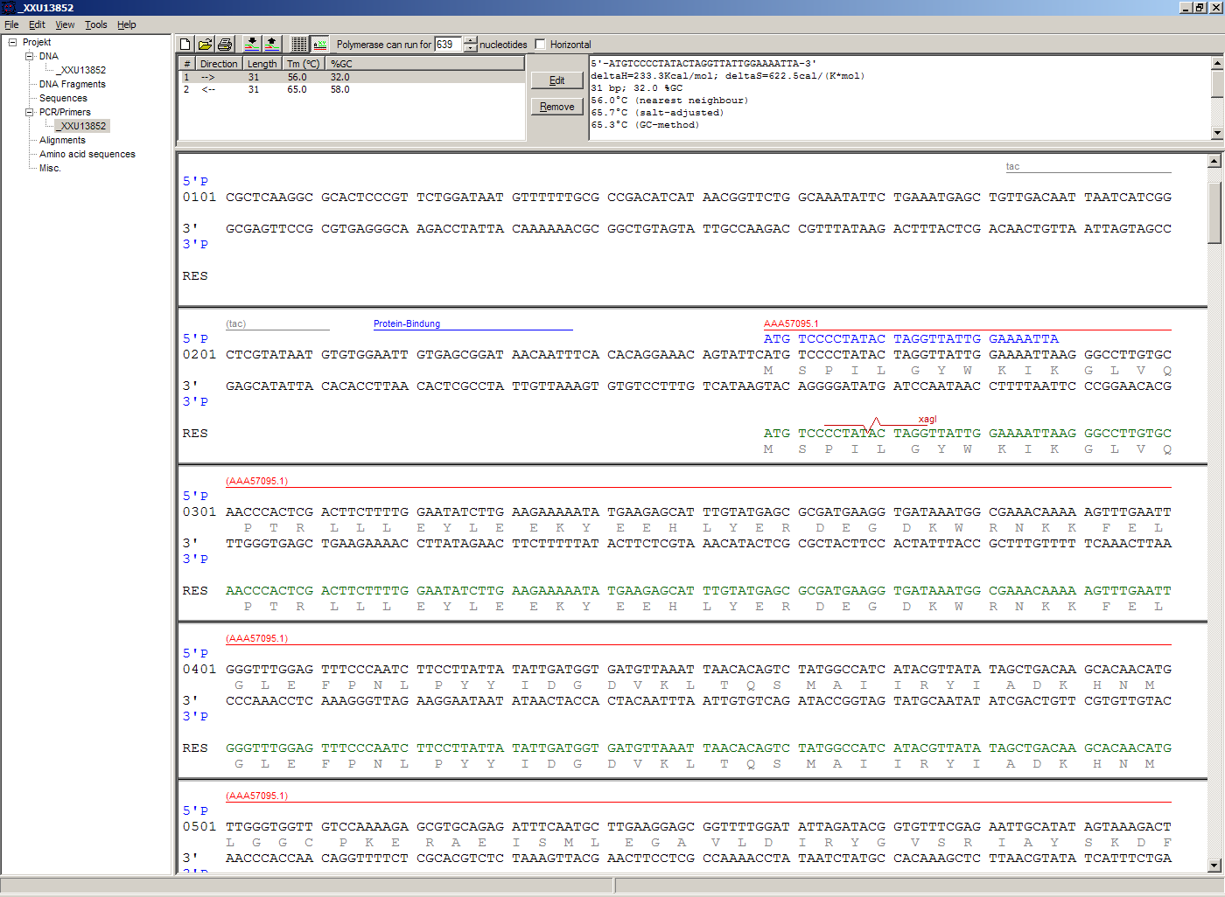
This module allows for designing primers and running virtual PCRs. It can be started from a DNA module via context menu of the DNA or sequence map, or through Tools/PCR. If a sequence is selected in the DNA module, one or more primers can be generated automatically upon startup of the PCR module. These will only be rough suggestions, and are in no way optimized by default.

Toolbar
- Enter new primer
- Open primer/sequence
- Print PCR
- Add a primer (you will have to open or enter the primer first)
- Export a primer (generate its sequence)
- Edit mode
- Show/hide features
- Polymerase running length
- Horizontal mode
The polymerase running length is the number of nucleotides the polymerase is allowed to run during the PCR in the elongation step. This is usually measured in minutes, but each polymerase runs at a different speed, which is why this information is given here in nuleotides. The value is initially computed automatically, but can be changed manually.

Primer list
The primer list (the upper left) shows all primers used in this PCR, as well as certain key properties of these. Selecting one of these primers will show more detailed information in the box on the right (see here for details). Double-clicking one of the primers will mark and show that primer in the sequence. A selected primer can be removed through the Remove button, or edited via the Edit button. A selected primer can also be exported via the Export button in the toolbar; a new sequence will be generated for that primer.
Caveat : The generated sequence is not stored anywhere automatically, it needs to be saved manually!
Caveat : To add a primer, use the Add button in the toolbar, or the Selection as new primer context menu. Merely editing the sequence (see below) is for editing existing primers only, it will not create new ones!

Sequence
The sequence consists of the following lines:
- Features of the template DNA (can be turned off in the toolbar)
- 5' primer
- Template DNA (5'→3')
- Amino acid sequence of the template
- Template DNA (3'→5')
- 3' primer
- Restriction sites of the resulting DNA
- Resulting DNA (shown in green)
- Amino acid sequence of the resulting DNA
Some special functions and properties of the PCR sequence display:
- The amino acid reading frame can be set as described here. This will affect both amino acid sequences shown (template and result).
- Only the two primer sequences can be edited; overwrite mode is mandatory, and deleting is disabeled.
- To delete a nucleotide, overwrite it with Space.
- The "." key will copy the matching template nucleotide to that position in the primer sequence.
- Matching primer nucleotides (that is, matching with the template) are shown in blue, mismatches in red.
- If (when not in edit mode) an empty span of the primer sequence is selected, it can be turned into a new primer via the context menu (Selection as new primer).
- The sequence of a restriction site can be inserted left or right of a selection (in edit mode, right or left of the cursor) via the context menu. A selection dialog for the desired enzyme will appear.
- A silent mutation can be introduced via the context menu.
Finally, the resulting DNA or amino acid sequence (the green sequence, which will be the one generated by the PCR) can be copied to the clipboard or generated as a new sequence (containing all features, restriction enzymes etc.) via the context menu.

Sequencing
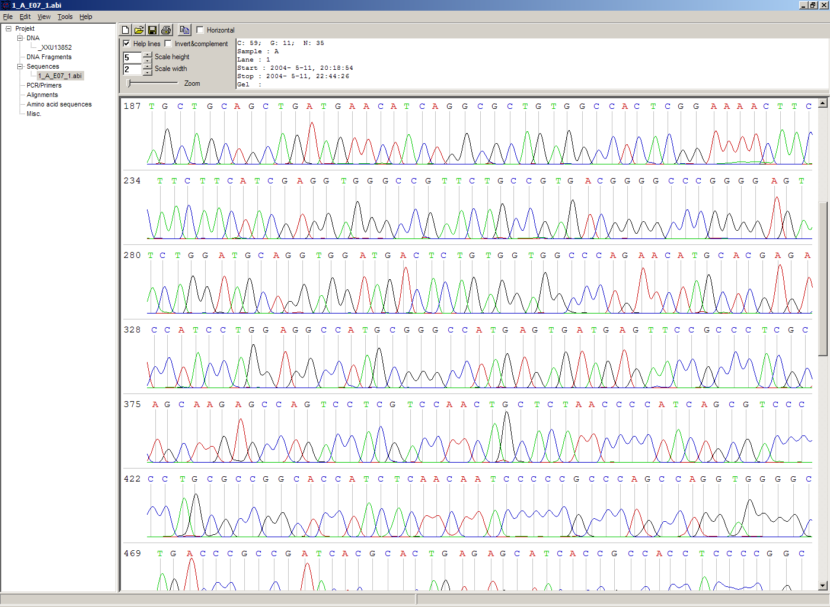
The sequencing module allows to view the data recorded by a sequence analyser. The data is loaded by importing the appropriate .abi/.ab1 file.

Display
The data is shown in the main sequence window. The text window on the upper right shows data stored in the file. On the left side, the following display options for the sequence are available:
Help lines | Gray vertial lines down from each sequence letter to the baseline. These can help to identify which letter belongs to which peak
Invert&complement | Shows the sequencing complement/inverted. Useful for Alignments
Scale height | Sets the height of the graphic display [unit in text lines]
Scale width | Sets the graphical points per data value. Default is 2; 1 would mean one pixel width per data point
Zoom | Sets the zoom factor for the data; useful to see small peaks

Toolbar
- Enter new sequence
- Open sequence
- Save sequence (see caveats)
- Copy sequence to clipboard
- Horizontal mode

Caveats
- Editing works in overwrite-mode only
- Saving will only store the sequence in the database, not the sequencer data (the peaks), due to memory concerns.

Alignments
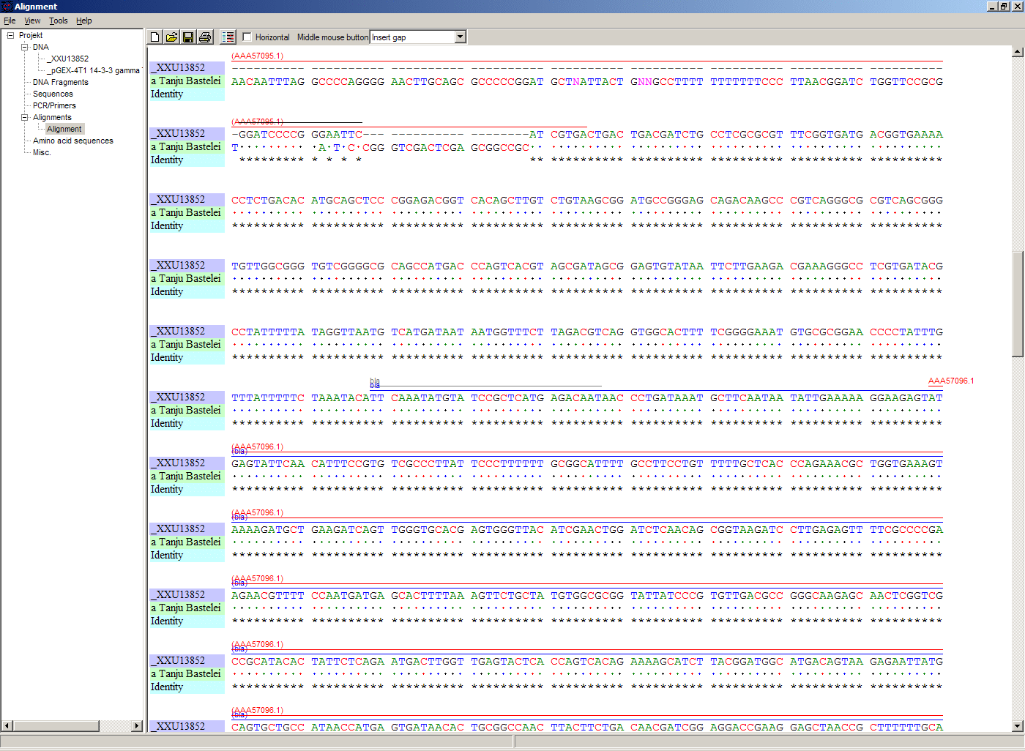
The alignment module displays alignments of DNA and amino acid sequences. It can be invoked through Tools/Alignment or Ctrl-G.

Settings dialog
The settings dialog will be invoked upon starting the module, or through the "settings" button in the toolbar. The sequences to align, their order, and the alignment algorithm and its paramaters can be chosen here. The following algorithms are available:
Clustal-W | This (default) algorithm generates alignments of high quality, but is rather slow for simple alignments, and sometimes stumbles over local alignments. It runs as an external program that will automatically be invoked by GENtle.
Smith-Waterman | An internal, fast, but simple algorithm for local alignments, that is, aligning one or multiple short sequences againast a long one. The long sequence has to be the first. It works great for checking sequencing data against the expected sequence.
Needlemann-Wunsch | An internal, fast, but simple algorithm for global alignments, that is, aligning sequences of roughly the same length (e.g., different alleles of a gene). As with Smith-Waterman, all alignments are made against the first sequence.
Caveat : Clicking OK in this dialog will recalculate the alignment; the previous alignment and all manual changes made to it will be lost.

Toolbar
Several functions and display options can be invoked in the tool bar:
- Enter sequence
- Open sequence
- Save sequence
- Print sequence
- Settings
- Horizontal mode
- Middle mouse button function

View menu
Some display options can be combined with each other:
- Bold (shows characters in bold)
- Mono (black-and-white mode)
- Conserverd (shows characters that match the one in the first line as dots)
- Identity (toggles the "identity" line)
Some of them exlude one another:
- Normal (shows colored text on white background)
- Inverted (shows white text on colored background)
Some other display options are planned, but not implemented as of now.

Sequence display
The sequence map can be altered through the context menu. These changes will only alter the display, not recalculate the alignment.
- Lines can be moved up or down
- Features for each line can be shown or hidden. By default, features for the first line are shown, features of the other lines are hidden.
- Gaps can be inserted or deleted, in this line, or all except this line. One of these four possible functions is additionally assigned to the middle mouse button; this setting can be changed in the toolbar.
- A double click on a character (not on a gap) opens the "source" window for that sequence (if available), marks and shows the position that was clicked in the alignment. This can be helpful for checking a sequencing.
Sequences can not be edited within the alignment module. For that, you will have to edit the original sequence, then re-run the alignment.

Calculators
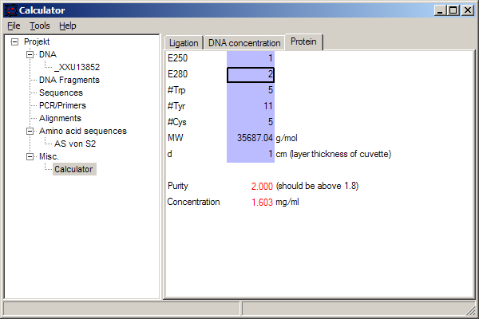
The calculator module can be invoked via Tools/Calculator. It contains several specialized spreadsheet-based calculators for typical tasks in molecular miology. The editable fields are shown in blue, the (major) results of the calculation are shown in red.

Ligation calculator
This calculator gives the amount (in µl) of vector and insert for a ligation, based on the length and concentration of each respectively, their desired ration and total mass of DNA. A typical ratio of insert:vector is 4:1 or 5:1.

DNA concentration calculator
This calculator gives the amount and putiry of DNA based on photometric absorption at 260 and 280 nm, respectively, as well as the dilution (in case one measures a 1:100 dilution of the original DNA sample) and a correction factor for different types of nucleic acids.

Protein calculator
This calculator gives the amount and purity of peptides/proteins based on photometric absorption at 250 and 280 nm, respectively, as well as the molecular weight of the peptide, the layer thickness of the cuvette used, and the number of tryptophanes, tyrosines and cysteines in the peptide.
This calculator can also be invoked via the Edit/Photmeter analysis menu in the Protein module, in which case GENtle automatically fills in all values except the layer thickness and the photometric values.

Data
This shows a codon table and a reverse codon table, both for standard code. This page can not be edited.

Virtual Gel
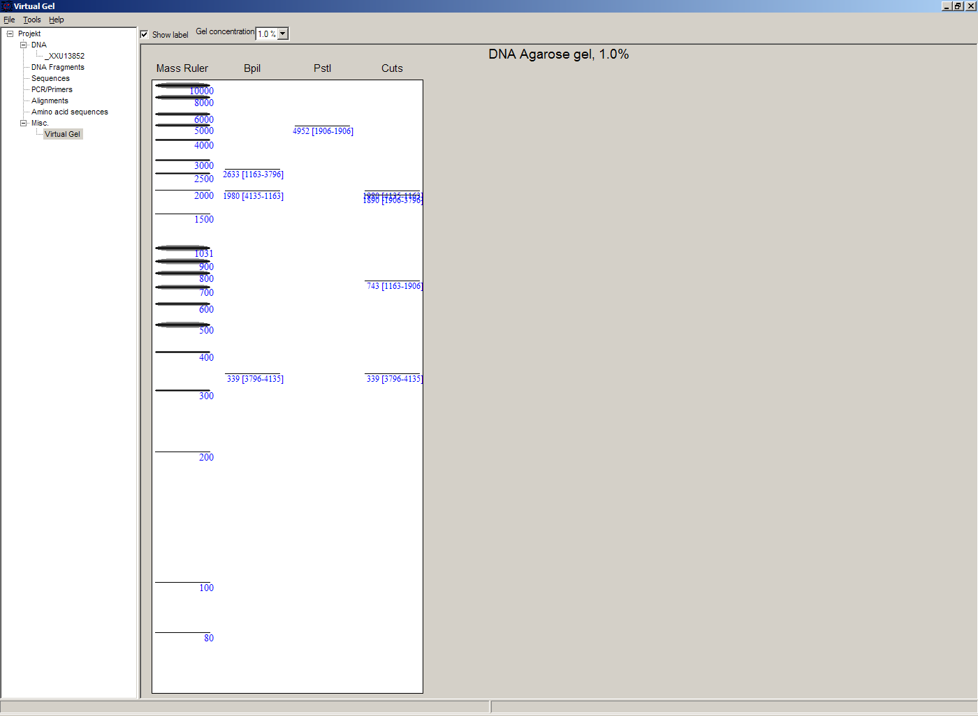
A "virtual agarose (DNA) gel" can be generated or expanded via the Restriction Assistant.
Within the gel viewer, gel concentration can be varied. Also, labelling can be turened on/off.

Image Viewer
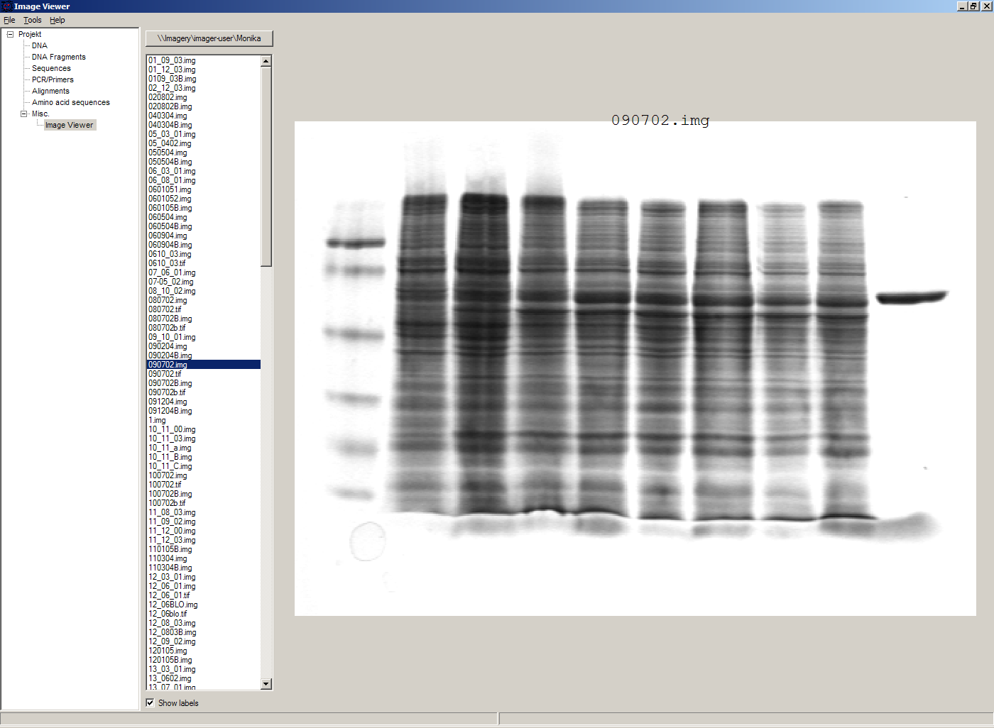
The Image Viewer module can be invoked via Tools/Image viewer. It can display images, such as gel photos, print them, or save them in another image format.
The viewer can read and write common formats, such as JPG, TIF, BMP, GIF, etc. In addition, it can read the IMG format used by the BioRad Molecular Analyst software.
The directory can be selected via the upper left button. The files in that directory are shown below. A single click on a file displays the image.
The context menu of the image contains entries to save or print the image, or copy it to the clipboard. For saving, PNG, TIF, BMP, and JPG are available formats, with PNG being the default, as it has the best lossless compression.
Labels of IMG images are shown on screen, print, and saved images by default. This can be changed through the "Show labels" checkbox beneath the file list.
An image can be inverted (black <=> white) through the "Invert" checkbox.

Web interface
The GENtle web interface lets you access DNA and amino acid sequences from NCBI (http://www.ncbi.com), as well as publications listed at PubMed (http://www.ncbi.nlm.nih.gov). The interface also covers BLAST searches.

NCBI
Chosing Nucleotide or Protein, entering a sequence name/keywords, and hitting Search/ENTER will show the NCBI search results for that query. More results (if any) can be browsed with >>.
Double-clicking an entry will download and open the (annotated) sequence.

PubMed
The PubMed option gives new entry fields for author(s) (written "Lastname Initials", separated by ","), and date limitations (years), as well as a result sort option.
Double-clicking an entry will open a web browser window with the respective PubMed abstract page.

BLAST
Running a BLAST search for a DNA or amino acid sequence will open a new tab in the web interface, showing a countdown for the time the BLAST results are expected to arrive. Once loaded, the results are displayed as simple alignments.
Double-clicking an entry will open the found sequence.

Tools

Ligation
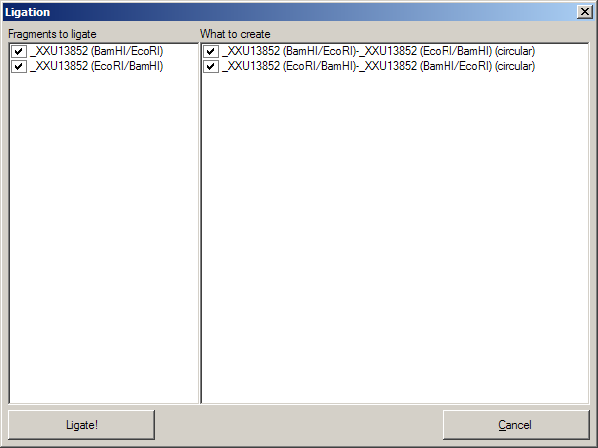
The ligation dialog is a means for virtually ligating two (or more) DNA fragments. It can be invoked via Tools/Ligation or Ctrl-L.
The left list shows all potential DNA sequences to be ligated. Some of these are automatically selected, but selection can be manually changed. The right list shows the possible products of a ligation of the selected sequences. Some circular products will be shown in two forms (A-B and B-A), which only differ visually.
The selected products will be generated as new sequences on clicking the Ligate button.

Options
Global program options can be altered via Tools/Options.

Global settings
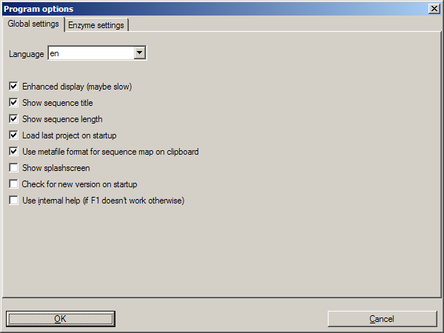
Option | Description
Language | Currently English and German are available
Enhanced display | Can be turned off on machines with very show graphics
Show sequence title | Displays the sequence title in the DNA map
Show sequence length | Displays the sequence length in the DNA map
Load last project on startup | Automatically loads the last used project when starting GENtle
Use metafile format | Generates a WMF when copying the DNA map instead of a bitmap
Show splashscreen | Shows the GENtle splashscreen when starting
Check for new version on startup | Checks (and downloads) a new GENtle version via internet on startup
Use internal help | Help should open in a browser window by default. If that doesn't work, check this option

Enzyme settings
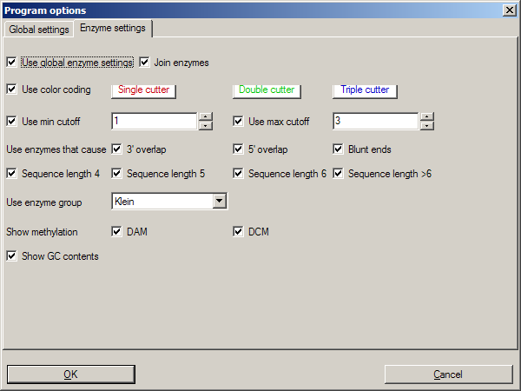
Here the gloal enzyme options can be selected. These can be overridden for an individual sequence in the sequence editor, where there is a tab identical to this one.

Option | Description
Use global enzyme settings | Turn most of the other options on this tab on or off globally
Join enzymes | In a DNA map, cuts of isoenzymes can be grouped together instead of displayed individually
Use color coding | Restriction enzymes can be shown in a color matching their number of cuts in a given sequence. The three buttons to the right of this option each hold a color choice dialog for single, double, and triple cutters.
Use min/max cutoff | Shows only enzymes that cut a minimum/maximum times
Sequence length | Shows only enzymes with recognition sequences of the selected lengths
Use enzyme group | Uses only enzymes from the selected enzyme group
Show methylation | Shows DAM and/or DCM methylation in map and sequence, in red
Show GC contents | shows the GC contents in the map

Databases (Open/save/manage)
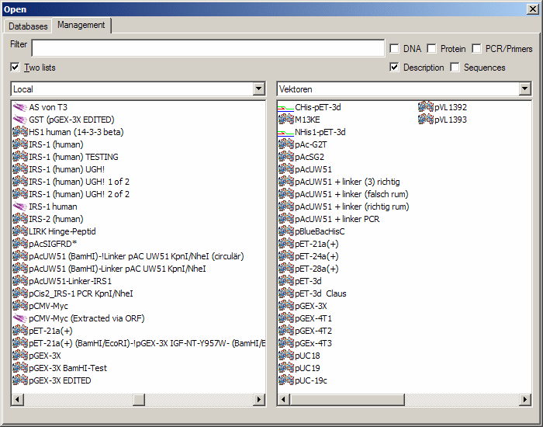
The GENtle database management dialog is where sequences are stored and retrieved. DNA and amino acid sequences, primers, alignments, and projects all go to databases, which can be local (for one computer only) or shared (used by the whole work group, institute, etc.).

Management
The "Management" tab can be reached through the File menu, the Tools/Manage database menu, the Ctrl-O and Ctrl-S keys ("open" and "save", respectively), or the appropriate buttons in the toolbar. The tab consists of two or three parts:

Filter
The filter section allows to filter the database entries so the list(s) below show only the matching entries.
The filter text box limits the shown sequences to those whose name (or desription or sequence, depending on the checkboxes) contain that text. Multiple search words are separated by a space (" ") and work as a logical AND. Thus, entering "pgex igf" in the filter text box shows only those sequences whose name (or description) contain both the word "pgex" and "igf". The search in not case-sensitive, so searching for "igf" or "IGF" will make no difference.
The checkboxes on the right limit the display to any combination of DNA, protein (amino acid sequences), and primers. If non of these is selected, all types of entries are shown, including alignments. As already described, search for text can be extended beyond the sequence name to description and the sequence itself through two other checkboxes, where description search is enabeled as default.

Lists
One or two lists are shown, depending on the appropriate checkbox above the left list. The database(s) to search/display can be selected via the drop-down box(es). One list with full width is good for an overview of a single database, whereas two lists are needed for moving and copying entries between databases; also, a search will be run on both databases simultaniously.
Entries will be sorted alphabetically. Every entry has a small icon associated with its type. There are icons for DNA, amino acid sequences, primers, and alignments. There is also a project icon, but these will only be shown when opening/saving a project.
A single entry can be selected by clicking with the left mouse button. When opening a file, a double click or pressing RETURN on a selected entry will open it. Multiple entries can be selected by dragging a rectangle with the mouse, or by holding down the SHIFT and/or CTRL keys. A multiple selection can be opened via RETURN.
Grabbing selected entries with the left mouse button and dragging them into the other list will move these entries to that database. To copy these entries, hold down the CTRL key when releasing the left mouse button over the target list.
Selected entries can be opened, renamed, and deleted via their context menu.

Save
If you save an entry to a database, there will be an additional line below the lists. It consits of a drop-down box with the database to save the entry to, and a text box for the name. The name of the database is remembered if you originally opened that entry from a database, otherwise the standard database is the default.
Saving an entry to a database where an entry with that name already exists will lead to the following:
- If the sequence of the entry in the database is exactly the same as the sequence of the entry you're trying to save, a message box will ask you if you really want to overwrite that entry.
- If the sequence of the entry in the database differs from the sequence of the entry you're trying to save, a message box will tell you that this action was preveneted. This will avoid accitential overwriting of an entry with a different sequence. If you are very certain you want to relpace that entry, you will have to delete the entry in the database manually via the context menu, as descibed above.

Databases
Currently, GENtle supports sqlite and MySQL databases, both of them freely available. Each has different advantages and disadvantages, though both are integrated seamlessly into GENtle. Once set up, all functions are available on all databases, no matter the type.
The "Databases" tab keeps a list of all the databases that can be accessed. New databases can be created, and existing can be added to or removed from that list. The exception is the local database, which is essential for the functioning of GENtle and therefore can not be removed. Removal of a database will not delete the database itself, only the entry in the list.
One of the databases in the list is the default database. The default database can be set by selecting its entry in the list, then clicking the As Default button. The default database can carry shared enzyme groups.

Sqlite
Sqlite is already integrated in GENtle, so no separate installation or setup of any kind is required. A sqlite database consists of a single file with the ending ".db". For each GENtle installation, a database ("local.db") is automatically created. New sqlite databases can be created, or existing ones added to GENtle, on the "Databases" tab in the dialog. To take such a database with you (e.g., for use at home or on a laptop), just copy the ".db" file. While sqlite databases are easy to set up and maintain, sharing them across a network tends to be slow, depending on the size of the database.

MySQL
MySQL is a professional client/server database system that will reliably store and serve millions of entries. It is ideal for shared databases, as even a huge number of stored sequences will not slow it down significantly, even across a network. Hovever, there are some steps required to use MySQL databases with GENtle:
- A "server" computer on your network, that is, a computer that is running most of the time, and preferably is not used for direct work. If the server is not running, or disconnected from the network, noone will be able to access the MySQL database and the sequences stored in it!
- The MySQL server software (4.1 works fine, other versions will likely do as well), which available for free here (http://dev.mysql.com/downloads/).
- Someone to configure the MySQL server (not as complicated as it sounds)
Once the MySQL setup is complete, MySQL databases can be created (by one) and added to all the GENtle clients that should have access.

Import
The import dialog is a standard "file open" dialog. It can be invoked via Files/Import or Ctrl-I.
Multiple files can be chosen to be imported in a row. GENtle will automatically try to determine the file type, but also a file type can be chosen manually.
Supported formats include:
- GenBank
- GenBank XML
- FASTA
- ABI/AB1 (popular sequencer output format)
- PDB (a 3D format, import as annotated sequence)
- Clone (old DOS program, proprietary format)
- Numerous other formats that will be imported as "sequence only", without annnotations, features etc.

Enter sequence
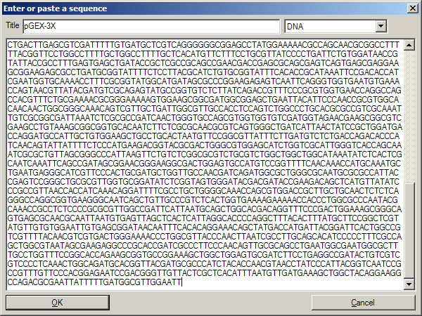
Enter a sequence manually.
This dialog to enter a sequence manually can be invoked via File/Enter sequence or Ctrl-N.
Beside the sequence, to be typed or pasted into the large text box, one can enter a title (name) for that sequence, and choose a type.
Types available are:
- DNA
- Amino acid sequence
- GenBank
- (GenBank) XML
- Primer
When chosing DNA, amino acids, or primer, all non-sequence characters, like blanks and numbers, are automatically removed.
Note : A primer has to be given the type "Primer", otherwise it will be added as DNA.

Find dialog
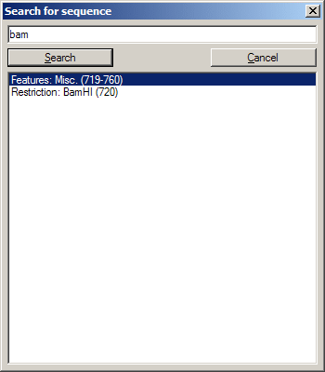
The Find dialog in DNA and amino acid sequence can be invoked via Ctrl-F or Edit/Search. It displays can find a string in
- the current sequence
- a feature name
- a feature description
In DNA sequence display, it also look in
- the reverse sequence
- the translated amino acid sequence(s)
- restriction enzyme names
The search is commenced automatically after changing the search string, if it is three or more characters long. For shorter search queries, the Search button has to be clicked.
Single-clicking on a search result will select and display the result in the sequence. A double click will exit the dialog, and open the sequence editor for features, or the enzyme management dialog for restriction enzymes.

Sequence editor
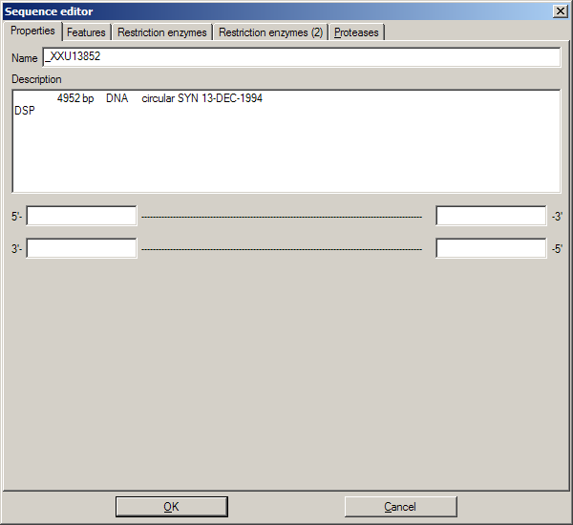
Sequence editor, properties tab.
The sequence editor holds the key to several properties of a sequence. It consists of several tabs, depending on the type of sequence, which can be DNA or amino acid.

Properties
Here, the title and description of the sequence can be altered. As for feature descriptions, the sequence description will make http references clickable.
For DNA sequences, sticky ends can be entered.

Features
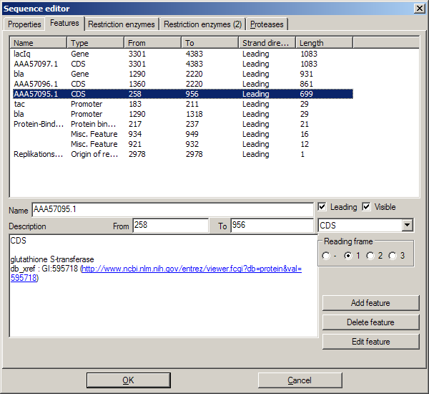
This tab shows a list of all features of the sequence. Features can be added, edited, and deleted. Most of the settings should be self-explanatory.
- The setting reading frame is only available when the type is set to "CDS" ("coding sequence").
- A leading sequence is read 5'→3'; leading unchecked, 3'→5'
- Edit feature will invoke an additional "Edit feature" dialog

Edit feature
- Fill color is the color of the feature; it will invoke a color choice dialog
- Type in sequence display determines how that feature is drawn in the sequence map
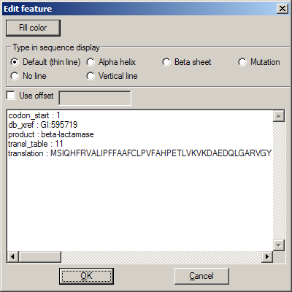
- Use offset sets the numbering for the first amino acid of the feature; useful if the feature marks a part of a protein
The list box below contains original data from GenBank format import.

Restriction enzymes
When editing a DNA sequence, two tabs with settings for restriction enzymes are available. The first one is identical to the enzyme management dialog. The second one is identical to the global enzyme settings tab, but contains the settings for this sequence alone. By default, its options are disabled, and the global options are used. By activation the options here, global settings are overridden.

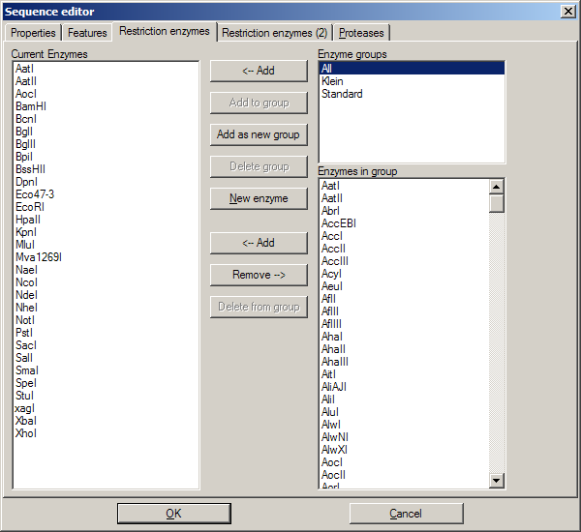  Sequence editor, enzyme settings tab. | 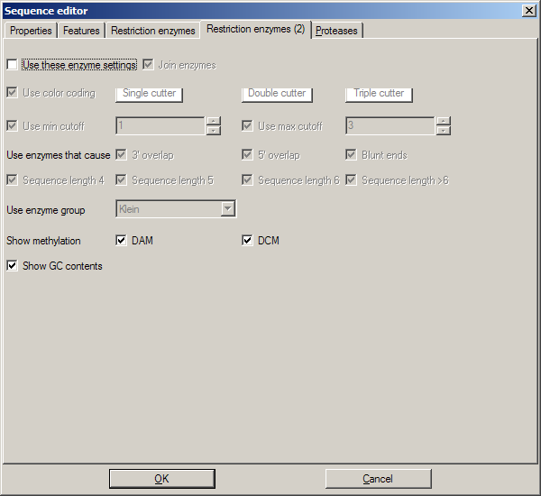  Sequence editor, enzyme settings (2).

Proteases
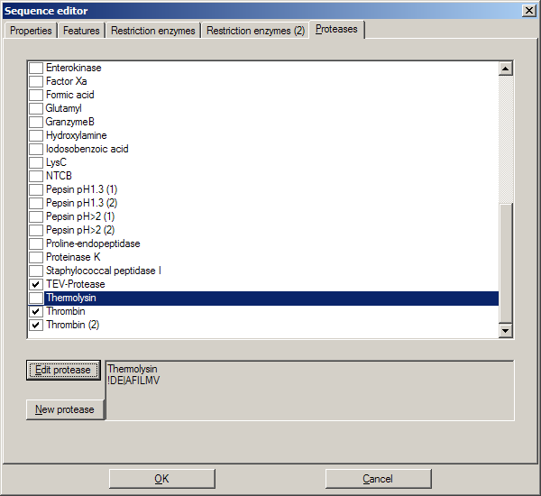
This tab holds a list of available proteases. Potential cleavage sites for selected (checked) proteases are shown in the sequence (not in the DNA map).
New proteases can be added similar to the following examples:
- Example : "Thermolysin"
  - Sequence for this protease : "!DE|AFILMV"
  - Explanation: "Not D or E", "cut", "then A, F, I, L, M, or V"
- Example: Proline-endopeptidase
  - Sequence for this protease : "HKR,P|!P"
  - Explanation : "H, K, or R", "then P", "cut", "then not P"

Restriction Assistant
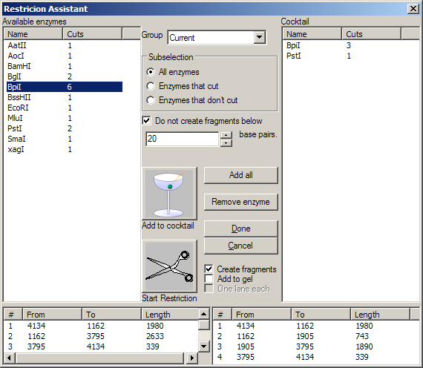
The Restriction Assistant can be invoked via menu Tools/Restriction Assistant, or through a click with the middle mouse button on a restriction site in the DNA map. For the latter, the selected enzyme is automatically selected in the list of "Available enzymes" (left). This list depends on the selections "Group" and "Subselection". It can be sorted by enzyme name or number of cuts by clicking on the respective column title. For a selected enzyme, the resulting fragments are shown in the lower left list.
The list on the right shows the contents of the "restriction cocktail", the enzymes already selected for cutting. The resulting fragments for these enzymes together are shown in the lower right list. The enzyme selected in the left list can be put in the cocktail via Add to cocktail; all enzymes from the left list can be added at once via Add all. An enzyme can be removed from the cocktail by selecting it in the right list, then via Remove enzyme.
Do not create fragments below ___ base pairs, when selected, limits the fragments generated to a minimum size. Done exits the restriction assistant while preserving the changes mage to the cocktail, whereas Cancel will void all changes made.
Start restriction (the scissors symbol) will initiate the simulated restriction. The result of this can be influenced by several further settings:
- Create fragments will generate the actual DNA sequences with their blunt/sticky ends that will result from a digestion with the cocktail. This option is pre-selected.
- Add to gel will add the fragments to a virtual gel, together in one lane.
- One lane each will alter the above so that each enzyme gets its own lane.
The restriction cocktail will be preserved so you can cut another DNA with that very enzyme combination, which is useful for an upcoming Ligation.

Projects
A project in GENtle is a collection of sequences that belong together, even is tey are in different databases. Projects can be
- loaded via File/Load Project or F11
- saved via File/Save Project or F12
- closed via File/Close Project
Depending on the options, the last used project is automatically opened wehn GENtle starts.
Projects consists of a list of sequences, not the sequences themselves. If a sequence is renamed, moved or deleted, GENtle will dispay a warning next time a project containing that sequence is opened.
For efficient use of sequencing primers, one can create a project that contains all available sequencing primers, and then refer to thast project in the Sequencing Primers dialog.

Edit primer dialog
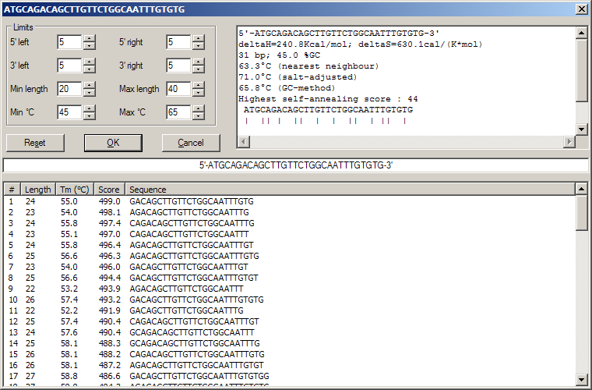
This dialog assists in optimizing a primer. For that reason, many variants of the primer are generated and can be examined.
The center line of the dialog shows the current variant of the primer; details of that variant are shown in the upper right box. OK will end the dialog, commiting that variant to the PCR module. Cancel will end the dialog and not change the PCR module. Reset will return the primer in the dialog to the variant the dialog was originally started with.
The list in the lower half of the dialog contains an automatically generated list of variants of the current primer, sorted by an arbitary score. The "region" of variants can be influenced by multiple settings in the upper left quarter of the dialog. Available settings include:
- The variation of the 5'-end of the primer to the right and to the left.
- The variation of the 3'-end of the primer to the right and to the left.
- The minimum and maximum length of the primer.
- The minimum and maximum melting temperature of the primer.
Any change of these settings will trigger a recalculation of possible variations. These variations are then evaluated and shown in the list in the lower half of the dialog. Double-clicking one of the varaiations will change the current variation in the center line, and the properties display in the upper right quarter of the dialog.

Properties display
This will display:
- The primer sequence in 5'→3' orientation
- The ΔH and ΔS values
- The length and GC contents of the primer
- The melting temperature, calculated according to the Nearest Neighbour method (usually best results, but only for longer primers)
- The melting temperature, calculated according to the salt-adjusted method (medicore results)
- The melting temperature, calculated according to the GC method (simplicistic)
- The highest self-annealing score (arbitary) and the display of that annealing
Caveat : Calculating primer melting temperatures is tricky. If one of the three methods gives a totally different result than the other two, ignore it. Also, the melting temperature is only calculated for the 3'-end of the primer that anneals with the sequence!

Printing
Sequence and DNA maps can be printed via the respective context menus or the File menu.
For DNA sequences, a report can be printed via File/Print report. It contains the DNA map and a list of the features annotated in the sequence. This can be useful for a detailed overview of the sequence where the sequence itself is not required.

Enzyme management
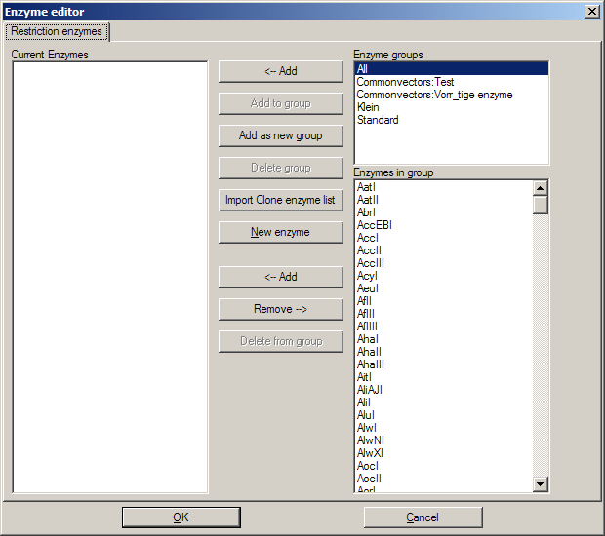
The enzyme editor for enzyme management, both globally and per DNA sequence, is divided into three lists:
- A list of enzyme groups (top right)
- A list of enzymes in that group (bottom right)
- A list of current/temporary enzymes (left)
Enzymes can be copied into/removed from the left list throught the <--Add and Remove--> buttons. Enzymes can be deleted from a group (except All) via Delete from group, or added via New enzyme. A double click on an enzyme name in either list shows an enzyme properties dialog.
Enzymes from the left list can be added to a new or existing group via the respective buttons. All enzymes from a group can be added to the left list, and a group can be deleted.

Sequencing Primers
The sequencing primers dialog can add possible sequencing primers as features to a DNA sequence. What primers to add can be specified:
- The mimimum alignment (3') of a primer to the sequence. This means exact annealing!
- The database to search for primers. All primers from that database will be considered.
- Alternatively, use all primers that are part of a project in that database. That way, a range of primers across databases can be specified in a project and be considered as sequencing primers here.
- Primers that run in 5'→3' or 3'→5' direction.
You can also have the dialog remove old sequencing primers from the sequence. This can also be done manually through Edit/Remove sequencing primers in the DNA module. Note: Sequencing primers, if not removed, will be saved as features together with the sequence; they can still be removed lated, though.
Sequencing primers will display as yellow features, where the shade of yellow depends on their direction. The actual sequencing primer feature is only as long as the 3' annealing of the primer, so the primer might actually be longer than the feature towards the 5' end. For details, see the feature description, which contains the original primer sequence, among other data.

Silent Mutation
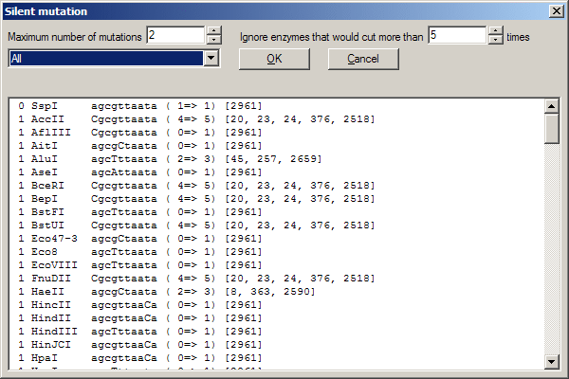
This dialog can find restriction enzymes that cut in a marked DNA sequence (context menu Selection/Show enzymes that cut here in the DNA module). It can also find alternate versions of the DNA which will translate into the same amino acid sequence, but contains a new restriction site (silent mutation). A chosen enzyme/mutation will appear in the sequence (DNA or primer, respectively) upon OK.
The results can be changed by
- changing which enzyme group to search
- limiting the number of times an enzyme may cut in the whole sequence
- limiting the number of mutations needed for a restriction site to manifest (PCR module only)

Automatic annotation
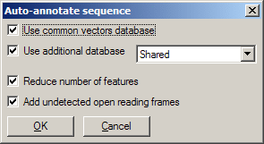
The automatic annotation feature can search a database of standard vectors (included with the GENtle package), and (optionally) a user-generated database, for feature sequences that are found in the currently opened DNA sequence. Recognized features are then annotated in the current sequence.
Invoked through Edit/Auto-annotate sequence or F9, a dialog opens, offering various settings:
- Wether or not to search the common vectors database
- Wether or not to use a user-generated database (and, if so, which one)
- Wether or not to reduce the number of generated features (recommended; otherwise, a lot of features are annotated)
- Wether or not to add unrecognized open reading frames as features

FAQ
FAQ - frequently asked questions.
Q: Why does GENtle try to connect to the internet all the time?
A: An internet connection is mandatory for BLAST- and ReBase-searches.
A: At the beginning of each GENtle session, a check for possible updates takes place, which also requires an internet connection. This can be turned off in the Tools/Options menu.
Q: Why can't I perform a BLAST search for the amino acids coded by the selected DNA sequence?
Q: Why can't I extract amino acids from the selected DNA sequence?
A: A reading frame must be selected.

GNU Free Documentation License
Version 1.2, November 2002
Copyright (C) 2000,2001,2002 Free Software Foundation, Inc.
59 Temple Place, Suite 330, Boston, MA 02111-1307 USA
Everyone is permitted to copy and distribute verbatim copies of this license document, but changing it is not allowed.
0. PREAMBLE
The purpose of this License is to make a manual, textbook, or other functional and useful document "free" in the sense of freedom: to assure everyone the effective freedom to copy and redistribute it, with or without modifying it, either commercially or noncommercially. Secondarily, this License preserves for the author and publisher a way to get credit for their work, while not being considered responsible for modifications made by others.
This License is a kind of "copyleft", which means that derivative works of the document must themselves be free in the same sense. It complements the GNU General Public License, which is a copyleft license designed for free software.
We have designed this License in order to use it for manuals for free software, because free software needs free documentation: a free program should come with manuals providing the same freedoms that the software does. But this License is not limited to software manuals; it can be used for any textual work, regardless of subject matter or whether it is published as a printed book. We recommend this License principally for works whose purpose is instruction or reference.
1. APPLICABILITY AND DEFINITIONS
This License applies to any manual or other work, in any medium, that contains a notice placed by the copyright holder saying it can be distributed under the terms of this License. Such a notice grants a world-wide, royalty-free license, unlimited in duration, to use that work under the conditions stated herein. The "Document", below, refers to any such manual or work. Any member of the public is a licensee, and is addressed as "you". You accept the license if you copy, modify or distribute the work in a way requiring permission under copyright law.
A "Modified Version" of the Document means any work containing the Document or a portion of it, either copied verbatim, or with modifications and/or translated into another language.
A "Secondary Section" is a named appendix or a front-matter section of the Document that deals exclusively with the relationship of the publishers or authors of the Document to the Document's overall subject (or to related matters) and contains nothing that could fall directly within that overall subject. (Thus, if the Document is in part a textbook of mathematics, a Secondary Section may not explain any mathematics.) The relationship could be a matter of historical connection with the subject or with related matters, or of legal, commercial, philosophical, ethical or political position regarding them.
The "Invariant Sections" are certain Secondary Sections whose titles are designated, as being those of Invariant Sections, in the notice that says that the Document is released under this License. If a section does not fit the above definition of Secondary then it is not allowed to be designated as Invariant. The Document may contain zero Invariant Sections. If the Document does not identify any Invariant Sections then there are none.
The "Cover Texts" are certain short passages of text that are listed, as Front-Cover Texts or Back-Cover Texts, in the notice that says that the Document is released under this License. A Front-Cover Text may be at most 5 words, and a Back-Cover Text may be at most 25 words.
A "Transparent" copy of the Document means a machine-readable copy, represented in a format whose specification is available to the general public, that is suitable for revising the document straightforwardly with generic text editors or (for images composed of pixels) generic paint programs or (for drawings) some widely available drawing editor, and that is suitable for input to text formatters or for automatic translation to a variety of formats suitable for input to text formatters. A copy made in an otherwise Transparent file format whose markup, or absence of markup, has been arranged to thwart or discourage subsequent modification by readers is not Transparent. An image format is not Transparent if used for any substantial amount of text. A copy that is not "Transparent" is called "Opaque".
Examples of suitable formats for Transparent copies include plain ASCII without markup, Texinfo input format, LaTeX input format, SGML or XML using a publicly available DTD, and standard-conforming simple HTML, PostScript or PDF designed for human modification. Examples of transparent image formats include PNG, XCF and JPG. Opaque formats include proprietary formats that can be read and edited only by proprietary word processors, SGML or XML for which the DTD and/or processing tools are not generally available, and the machine-generated HTML, PostScript or PDF produced by some word processors for output purposes only.
The "Title Page" means, for a printed book, the title page itself, plus such following pages as are needed to hold, legibly, the material this License requires to appear in the title page. For works in formats which do not have any title page as such, "Title Page" means the text near the most prominent appearance of the work's title, preceding the beginning of the body of the text.
A section "Entitled XYZ" means a named subunit of the Document whose title either is precisely XYZ or contains XYZ in parentheses following text that translates XYZ in another language. (Here XYZ stands for a specific section name mentioned below, such as "Acknowledgements", "Dedications", "Endorsements", or "History".) To "Preserve the Title" of such a section when you modify the Document means that it remains a section "Entitled XYZ" according to this definition.
The Document may include Warranty Disclaimers next to the notice which states that this License applies to the Document. These Warranty Disclaimers are considered to be included by reference in this License, but only as regards disclaiming warranties: any other implication that these Warranty Disclaimers may have is void and has no effect on the meaning of this License.
2. VERBATIM COPYING
You may copy and distribute the Document in any medium, either commercially or noncommercially, provided that this License, the copyright notices, and the license notice saying this License applies to the Document are reproduced in all copies, and that you add no other conditions whatsoever to those of this License. You may not use technical measures to obstruct or control the reading or further copying of the copies you make or distribute. However, you may accept compensation in exchange for copies. If you distribute a large enough number of copies you must also follow the conditions in section 3.
You may also lend copies, under the same conditions stated above, and you may publicly display copies.
3. COPYING IN QUANTITY
If you publish printed copies (or copies in media that commonly have printed covers) of the Document, numbering more than 100, and the Document's license notice requires Cover Texts, you must enclose the copies in covers that carry, clearly and legibly, all these Cover Texts: Front-Cover Texts on the front cover, and Back-Cover Texts on the back cover. Both covers must also clearly and legibly identify you as the publisher of these copies. The front cover must present the full title with all words of the title equally prominent and visible. You may add other material on the covers in addition. Copying with changes limited to the covers, as long as they preserve the title of the Document and satisfy these conditions, can be treated as verbatim copying in other respects.
If the required texts for either cover are too voluminous to fit legibly, you should put the first ones listed (as many as fit reasonably) on the actual cover, and continue the rest onto adjacent pages.
If you publish or distribute Opaque copies of the Document numbering more than 100, you must either include a machine-readable Transparent copy along with each Opaque copy, or state in or with each Opaque copy a computer-network location from which the general network-using public has access to download using public-standard network protocols a complete Transparent copy of the Document, free of added material. If you use the latter option, you must take reasonably prudent steps, when you begin distribution of Opaque copies in quantity, to ensure that this Transparent copy will remain thus accessible at the stated location until at least one year after the last time you distribute an Opaque copy (directly or through your agents or retailers) of that edition to the public.
It is requested, but not required, that you contact the authors of the Document well before redistributing any large number of copies, to give them a chance to provide you with an updated version of the Document.
4. MODIFICATIONS
You may copy and distribute a Modified Version of the Document under the conditions of sections 2 and 3 above, provided that you release the Modified Version under precisely this License, with the Modified Version filling the role of the Document, thus licensing distribution and modification of the Modified Version to whoever possesses a copy of it. In addition, you must do these things in the Modified Version:
- A. Use in the Title Page (and on the covers, if any) a title distinct from that of the Document, and from those of previous versions (which should, if there were any, be listed in the History section of the Document). You may use the same title as a previous version if the original publisher of that version gives permission.
- B. List on the Title Page, as authors, one or more persons or entities responsible for authorship of the modifications in the Modified Version, together with at least five of the principal authors of the Document (all of its principal authors, if it has fewer than five), unless they release you from this requirement.
- C. State on the Title page the name of the publisher of the Modified Version, as the publisher.
- D. Preserve all the copyright notices of the Document.
- E. Add an appropriate copyright notice for your modifications adjacent to the other copyright notices.
- F. Include, immediately after the copyright notices, a license notice giving the public permission to use the Modified Version under the terms of this License, in the form shown in the Addendum below.
- G. Preserve in that license notice the full lists of Invariant Sections and required Cover Texts given in the Document's license notice.
- H. Include an unaltered copy of this License.
- I. Preserve the section Entitled "History", Preserve its Title, and add to it an item stating at least the title, year, new authors, and publisher of the Modified Version as given on the Title Page. If there is no section Entitled "History" in the Document, create one stating the title, year, authors, and publisher of the Document as given on its Title Page, then add an item describing the Modified Version as stated in the previous sentence.
- J. Preserve the network location, if any, given in the Document for public access to a Transparent copy of the Document, and likewise the network locations given in the Document for previous versions it was based on. These may be placed in the "History" section. You may omit a network location for a work that was published at least four years before the Document itself, or if the original publisher of the version it refers to gives permission.
- K. For any section Entitled "Acknowledgements" or "Dedications", Preserve the Title of the section, and preserve in the section all the substance and tone of each of the contributor acknowledgements and/or dedications given therein.
- L. Preserve all the Invariant Sections of the Document, unaltered in their text and in their titles. Section numbers or the equivalent are not considered part of the section titles.
- M. Delete any section Entitled "Endorsements". Such a section may not be included in the Modified Version.
- N. Do not retitle any existing section to be Entitled "Endorsements" or to conflict in title with any Invariant Section.
- O. Preserve any Warranty Disclaimers.
If the Modified Version includes new front-matter sections or appendices that qualify as Secondary Sections and contain no material copied from the Document, you may at your option designate some or all of these sections as invariant. To do this, add their titles to the list of Invariant Sections in the Modified Version's license notice. These titles must be distinct from any other section titles.
You may add a section Entitled "Endorsements", provided it contains nothing but endorsements of your Modified Version by various parties--for example, statements of peer review or that the text has been approved by an organization as the authoritative definition of a standard.
You may add a passage of up to five words as a Front-Cover Text, and a passage of up to 25 words as a Back-Cover Text, to the end of the list of Cover Texts in the Modified Version. Only one passage of Front-Cover Text and one of Back-Cover Text may be added by (or through arrangements made by) any one entity. If the Document already includes a cover text for the same cover, previously added by you or by arrangement made by the same entity you are acting on behalf of, you may not add another; but you may replace the old one, on explicit permission from the previous publisher that added the old one.
The author(s) and publisher(s) of the Document do not by this License give permission to use their names for publicity for or to assert or imply endorsement of any Modified Version.
5. COMBINING DOCUMENTS
You may combine the Document with other documents released under this License, under the terms defined in section 4 above for modified versions, provided that you include in the combination all of the Invariant Sections of all of the original documents, unmodified, and list them all as Invariant Sections of your combined work in its license notice, and that you preserve all their Warranty Disclaimers.
The combined work need only contain one copy of this License, and multiple identical Invariant Sections may be replaced with a single copy. If there are multiple Invariant Sections with the same name but different contents, make the title of each such section unique by adding at the end of it, in parentheses, the name of the original author or publisher of that section if known, or else a unique number. Make the same adjustment to the section titles in the list of Invariant Sections in the license notice of the combined work.
In the combination, you must combine any sections Entitled "History" in the various original documents, forming one section Entitled "History"; likewise combine any sections Entitled "Acknowledgements", and any sections Entitled "Dedications". You must delete all sections Entitled "Endorsements."
6. COLLECTIONS OF DOCUMENTS
You may make a collection consisting of the Document and other documents released under this License, and replace the individual copies of this License in the various documents with a single copy that is included in the collection, provided that you follow the rules of this License for verbatim copying of each of the documents in all other respects.
You may extract a single document from such a collection, and distribute it individually under this License, provided you insert a copy of this License into the extracted document, and follow this License in all other respects regarding verbatim copying of that document.

7. AGGREGATION WITH INDEPENDENT WORKS
A compilation of the Document or its derivatives with other separate and independent documents or works, in or on a volume of a storage or distribution medium, is called an "aggregate" if the copyright resulting from the compilation is not used to limit the legal rights of the compilation's users beyond what the individual works permit. When the Document is included in an aggregate, this License does not apply to the other works in the aggregate which are not themselves derivative works of the Document.
If the Cover Text requirement of section 3 is applicable to these copies of the Document, then if the Document is less than one half of the entire aggregate, the Document's Cover Texts may be placed on covers that bracket the Document within the aggregate, or the electronic equivalent of covers if the Document is in electronic form. Otherwise they must appear on printed covers that bracket the whole aggregate.
8. TRANSLATION
Translation is considered a kind of modification, so you may distribute translations of the Document under the terms of section 4. Replacing Invariant Sections with translations requires special permission from their copyright holders, but you may include translations of some or all Invariant Sections in addition to the original versions of these Invariant Sections. You may include a translation of this License, and all the license notices in the Document, and any Warranty Disclaimers, provided that you also include the original English version of this License and the original versions of those notices and disclaimers. In case of a disagreement between the translation and the original version of this License or a notice or disclaimer, the original version will prevail.
If a section in the Document is Entitled "Acknowledgements", "Dedications", or "History", the requirement (section 4) to Preserve its Title (section 1) will typically require changing the actual title.
9. TERMINATION
You may not copy, modify, sublicense, or distribute the Document except as expressly provided for under this License. Any other attempt to copy, modify, sublicense or distribute the Document is void, and will automatically terminate your rights under this License. However, parties who have received copies, or rights, from you under this License will not have their licenses terminated so long as such parties remain in full compliance.
10. FUTURE REVISIONS OF THIS LICENSE
The Free Software Foundation may publish new, revised versions of the GNU Free Documentation License from time to time. Such new versions will be similar in spirit to the present version, but may differ in detail to address new problems or concerns. See http://www.gnu.org/copyleft/.
Each version of the License is given a distinguishing version number. If the Document specifies that a particular numbered version of this License "or any later version" applies to it, you have the option of following the terms and conditions either of that specified version or of any later version that has been published (not as a draft) by the Free Software Foundation. If the Document does not specify a version number of this License, you may choose any version ever published (not as a draft) by the Free Software Foundation.
How to use this License for your documents
To use this License in a document you have written, include a copy of the License in the document and put the following copyright and license notices just after the title page:
Copyright (c) YEAR YOUR NAME.
Permission is granted to copy, distribute and/or modify this document
under the terms of the GNU Free Documentation License, Version 1.2
or any later version published by the Free Software Foundation;
with no Invariant Sections, no Front-Cover Texts, and no Back-Cover
Texts. A copy of the license is included in the section entitled "GNU
Free Documentation License".
If you have Invariant Sections, Front-Cover Texts and Back-Cover Texts, replace the "with...Texts." line with this:
with the Invariant Sections being LIST THEIR TITLES, with the
Front-Cover Texts being LIST, and with the Back-Cover Texts being LIST.
If you have Invariant Sections without Cover Texts, or some other combination of the three, merge those two alternatives to suit the situation.
If your document contains nontrivial examples of program code, we recommend releasing these examples in parallel under your choice of free software license, such as the GNU General Public License, to permit their use in free software.

